Caddington bakers
Fred Howell and William Ford
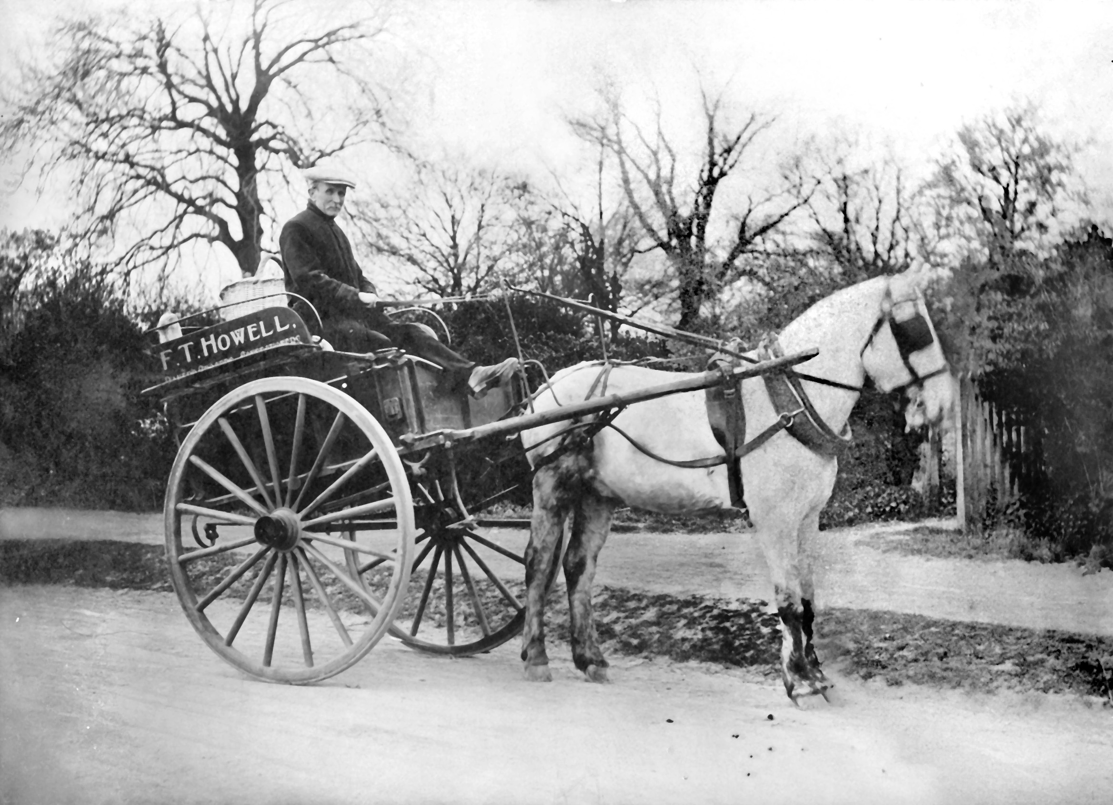
Fred Howell circa 1910

Frederick (Fred) Howell (b. c1862) and his wife Teresa (neé George) with their daughter Selina Pricilla moved from Swavesey in Cambridgeshire to Caddington circa 1905 when Selina was 18 years old where they bought the post office, general stores and bakery.
William Alfred Ford was born in Eastney, Hampshire in 1886. The family moved to Reepham in Norfolk where William’s father ran a bakery from their home. William had the opportunity to play football for Norwich City FC but decided instead to move to Luton where he managed a bakery in High Town. It was here that he met his future wife, Selina, when she came to purchase yeast for her father’s bakery. They married, circa 1913/14 and bought the business in Caddington from Selina’s parents who then moved to Dunstable. They ran the business until they retired in 1947/8 at which time they moved to Stopsley.
William and Selina had a daughter Joan born in l916 and a son John born 1926.
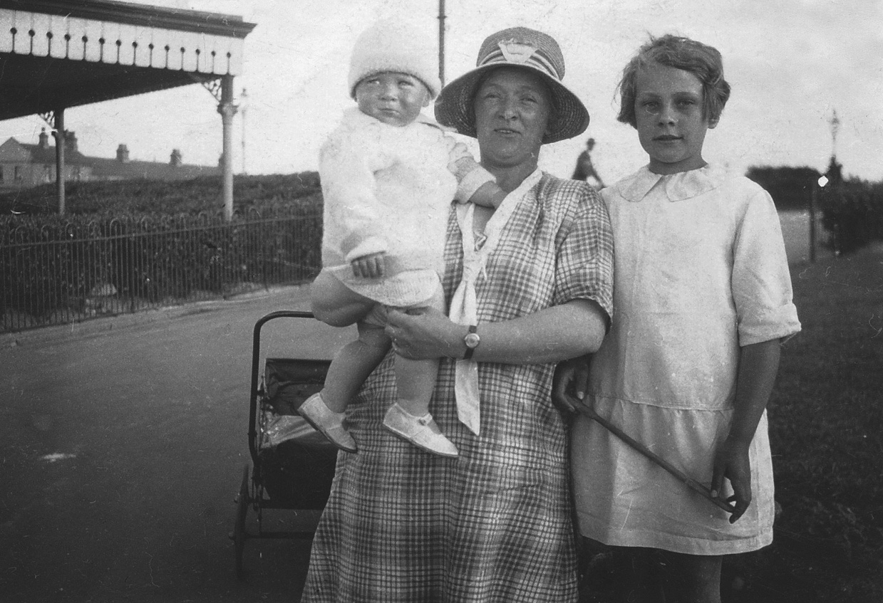
Selina Ford with John & Joan circa 1927
Selina ran the post office and store while William ran the bakery. The bakery was in the basement of the house with access from the pavement via a trap door.. The whole baking operation was done entirely by hand without the aid of machinery. There was one large oven and the heat it produced melted the ice and snow from the pavement in front of the shop. The bread was delivered to the surrounding villages by horse and cart and later by a chain driven Trojan.
They cooked many a Christmas turkey, in the bread oven, for the villagers. They also charged accumulator batteries as part of the shop service. Pigs were kept in the back yard along with rabbits and chickens. The pigs were slaughtered on the premises and presumably the bacon sold in the shop.
A well known local character Frankie Cooper, who had Downs Syndrome, ‘helped’ in the bakery and lived with the family for periods of time.
Joan later became Mrs. Woodfield, she first met her future husband John at a party at Brian Samm’s whose parents farmed at Church Farm Caddington. Joan died in Stopsley in 2009 aged 92, her brother John lived in Kensworth where he died in the late 1980s.

This article was written by Robert Woodfield, Joan’s son. Selina was his maternal grandmother.

